

CYBERSTER INTERNSHIP
WEEK 2 REPORT

WEEK 2 PROGRESS REPORT: SOC OPERATIONS & SIEM FOUNDATIONS
​Program: Cyberster Blue Team Internship
Prepared by: Prudence Nthenya
CSI-B1-479
Date: March 30, 2026
Subject: Detection, Custom Rules, and Log Analysis Implementation

1. EXECUTIVE SUMMARY
​Week 2 transitioned the security environment from a basic "up-and-running" state to a functional Security Operations Center (SOC) posture. The primary focus was on configuring File Integrity Monitoring (FIM), developing Custom Detection Rules, performing Cross-Platform Log Analysis, and implementing Automated Active Response to mitigate real-time threats.

​2. FILE INTEGRITY MONITORING (FIM)
​Objective: To monitor critical system files for unauthorized changes, providing a forensic trail of "who, what, and when."

​2.1 Configuration Details
​The syscheck module within ossec.conf was modified to move from scheduled scans to a real-time detection posture.

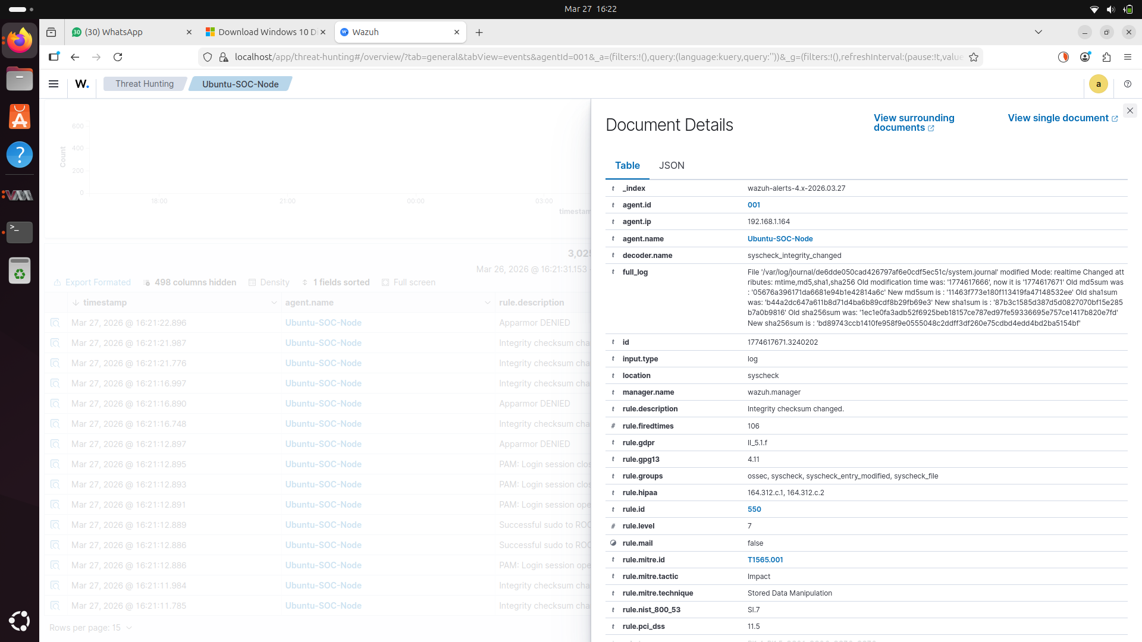

2.2 Results & Analysis
​Testing involved creating and modifying files within /etc. Wazuh successfully captured the full forensic context, including the file path, the specific user account active during the change, and the exact timestamp.
​Note: Real-time monitoring was prioritized for /etc to detect unauthorized privilege escalations or SSH configuration tampering.

​3. CUSTOM DETECTION RULES
​Objective: To move beyond generic alerts and target specific behaviors relevant to the lab's threat model.

​3.1 Rule Engineering
​Custom rules were added to /var/ossec/etc/rules/local_rules.xml using IDs above 100000.
​Rule 100001 (User Creation): Detected the addition of new accounts on Linux, mapped to MITRE ATT&CK T1136.
​Rule 100002 (Brute Force): A frequency-based rule triggering after 5 failed SSH attempts within a 120-second window.

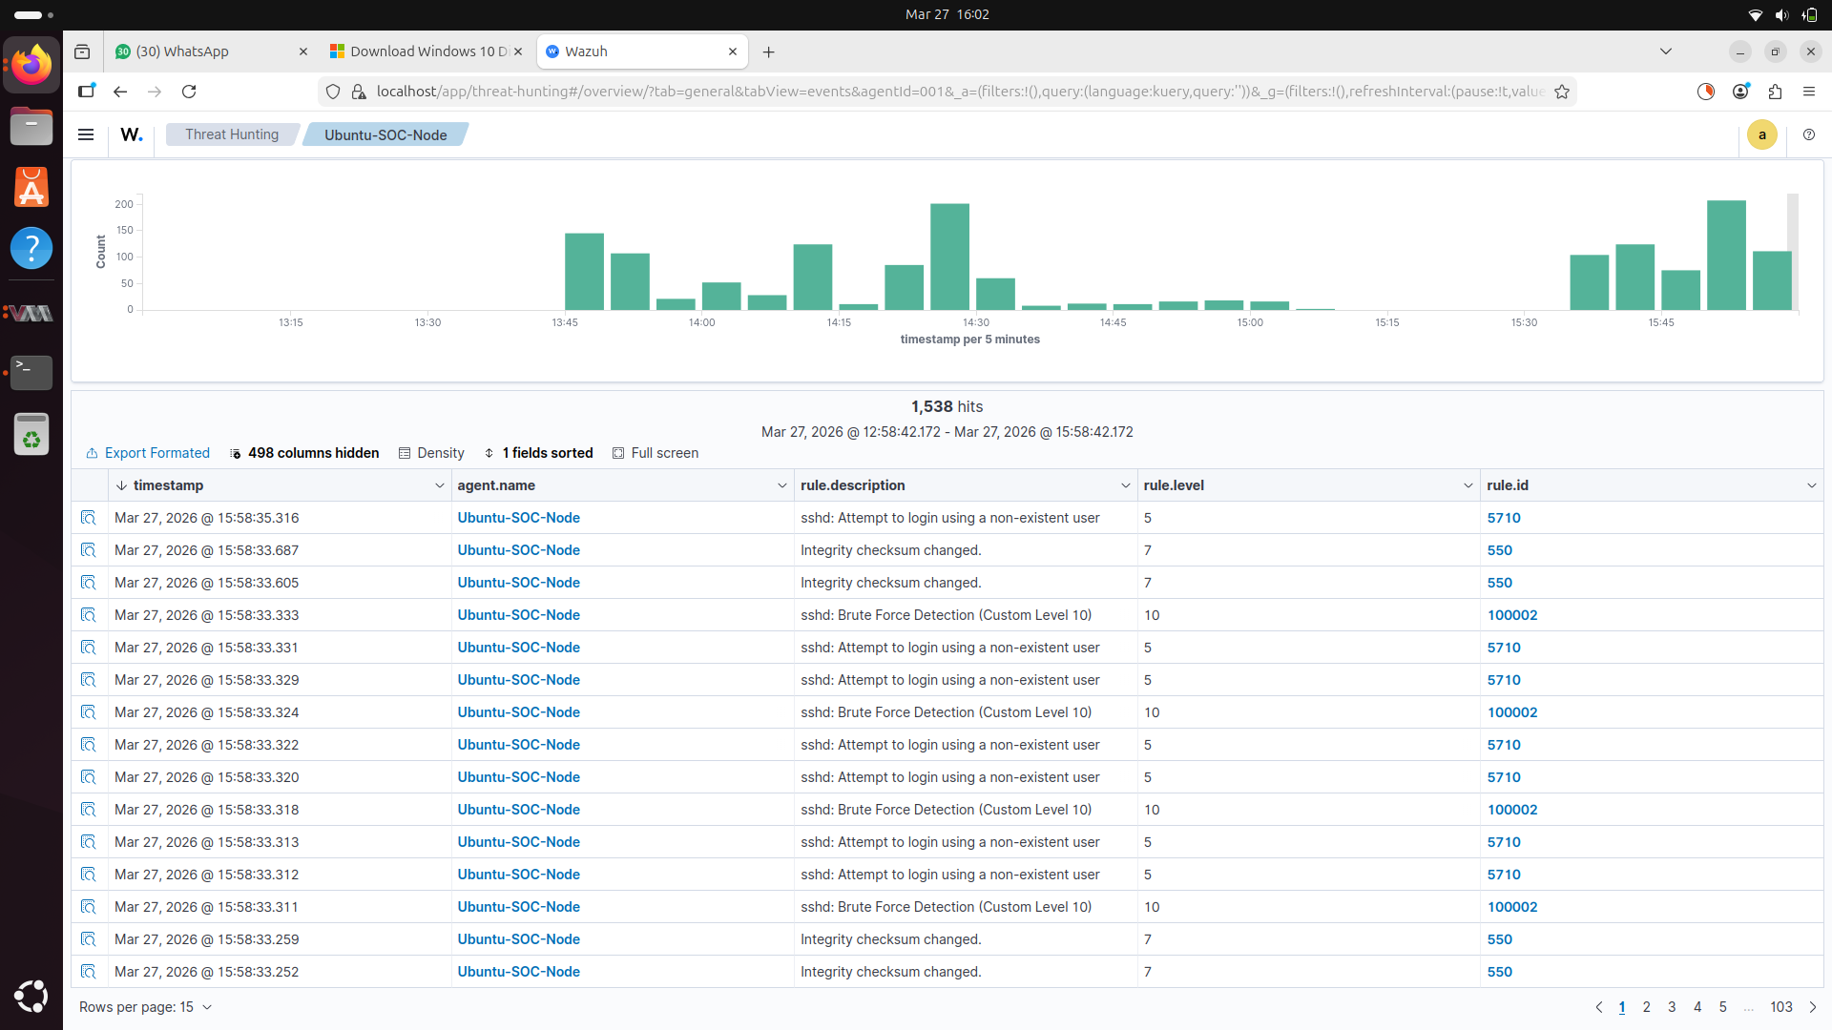
​Rule 100003 (USB Detection): Monitored Windows Event ID 2003 to alert on unauthorized hardware insertion.


​

3.2 Tuning & Optimization
​Initial testing of the SSH rule required adjustment of the timeframe to reduce false positives from legitimate administrative errors, ensuring high-fidelity alerts for actual brute force attempts.

​4. LOG ANALYSIS & THREAT HUNTING
​Objective: To correlate disparate log data into a coherent narrative of suspicious activity.

​4.1 Windows Event Analysis
​Focused on critical Security Event IDs:
​4625: Analyzed failure codes to distinguish between "User Does Not Exist" and "Wrong Password."
​4720: Verified the specific administrator account responsible for new user provisioning.
​4672: Flagged logins with administrative "Special Privileges."
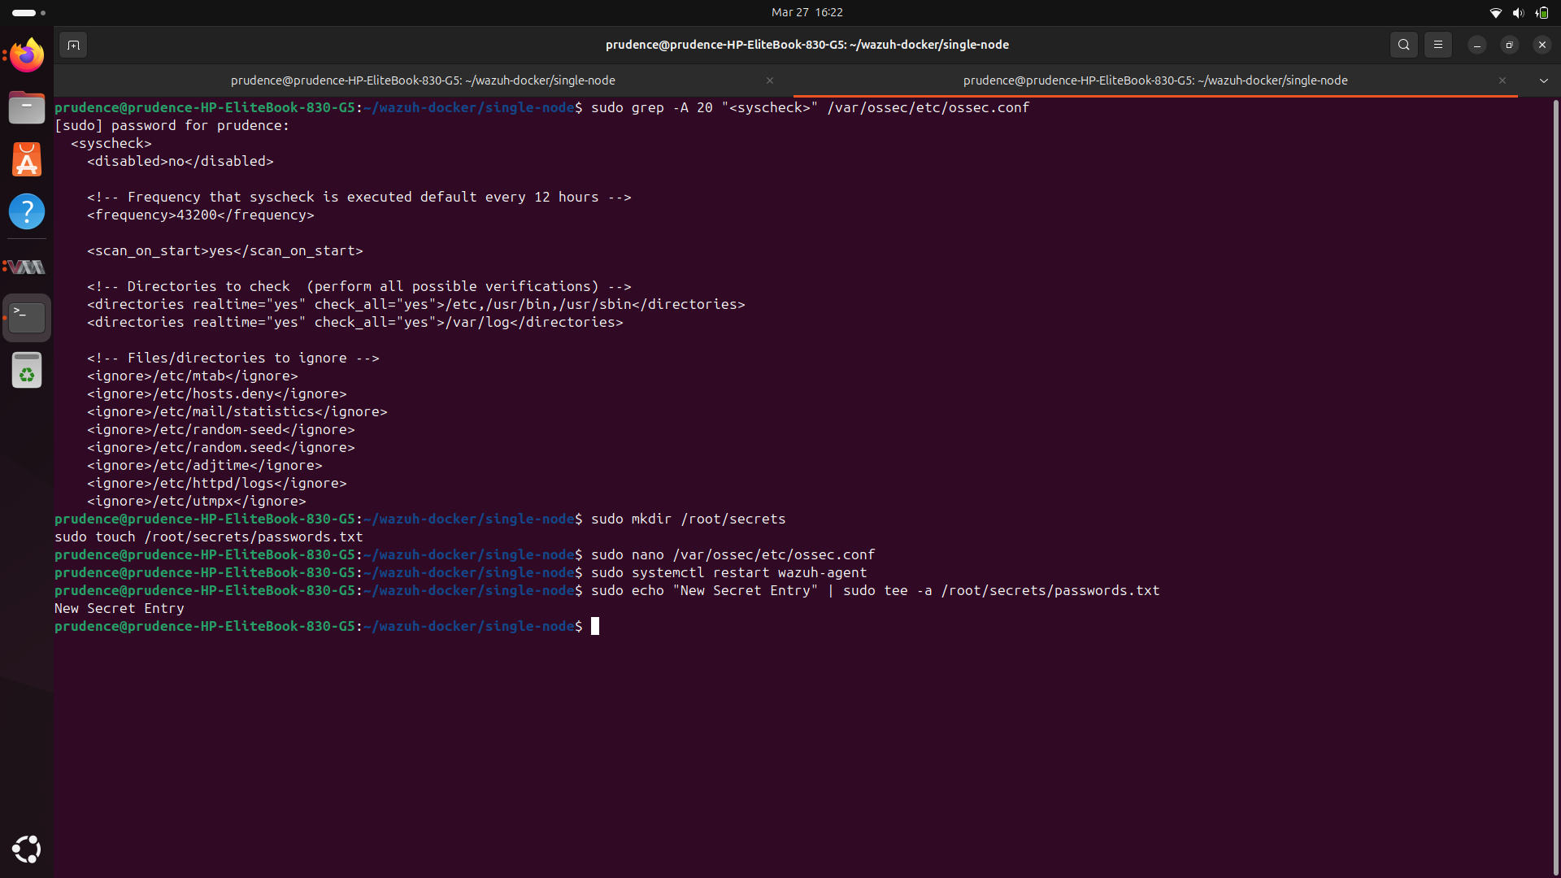

​4.2 Timeline of Suspicious Activity
​Using the Wazuh Threat Hunting module, a correlation was established between repeated failed logins on the Windows agent and a subsequent successful login from the same source IP, indicating a successful password-guessing attack.

​5. AUTOMATED ACTIVE RESPONSE
​Objective: To transition from passive alerting to active threat mitigation.
​5.1 Technical Implementation
​The Wazuh Manager was configured to trigger the firewall-drop script when Rule 100002 (SSH Brute Force) was satisfied.
​Action: The Manager commanded the Linux Agent to update iptables.
​Verification: Upon the 6th failed login from the Kali VM, the IP was successfully blocked.
​Command Verification: sudo iptables -L confirmed the Kali IP was present in the drop list.
​Timeout: The block was set to 300 seconds to prevent permanent accidental lockouts during the lab phase.
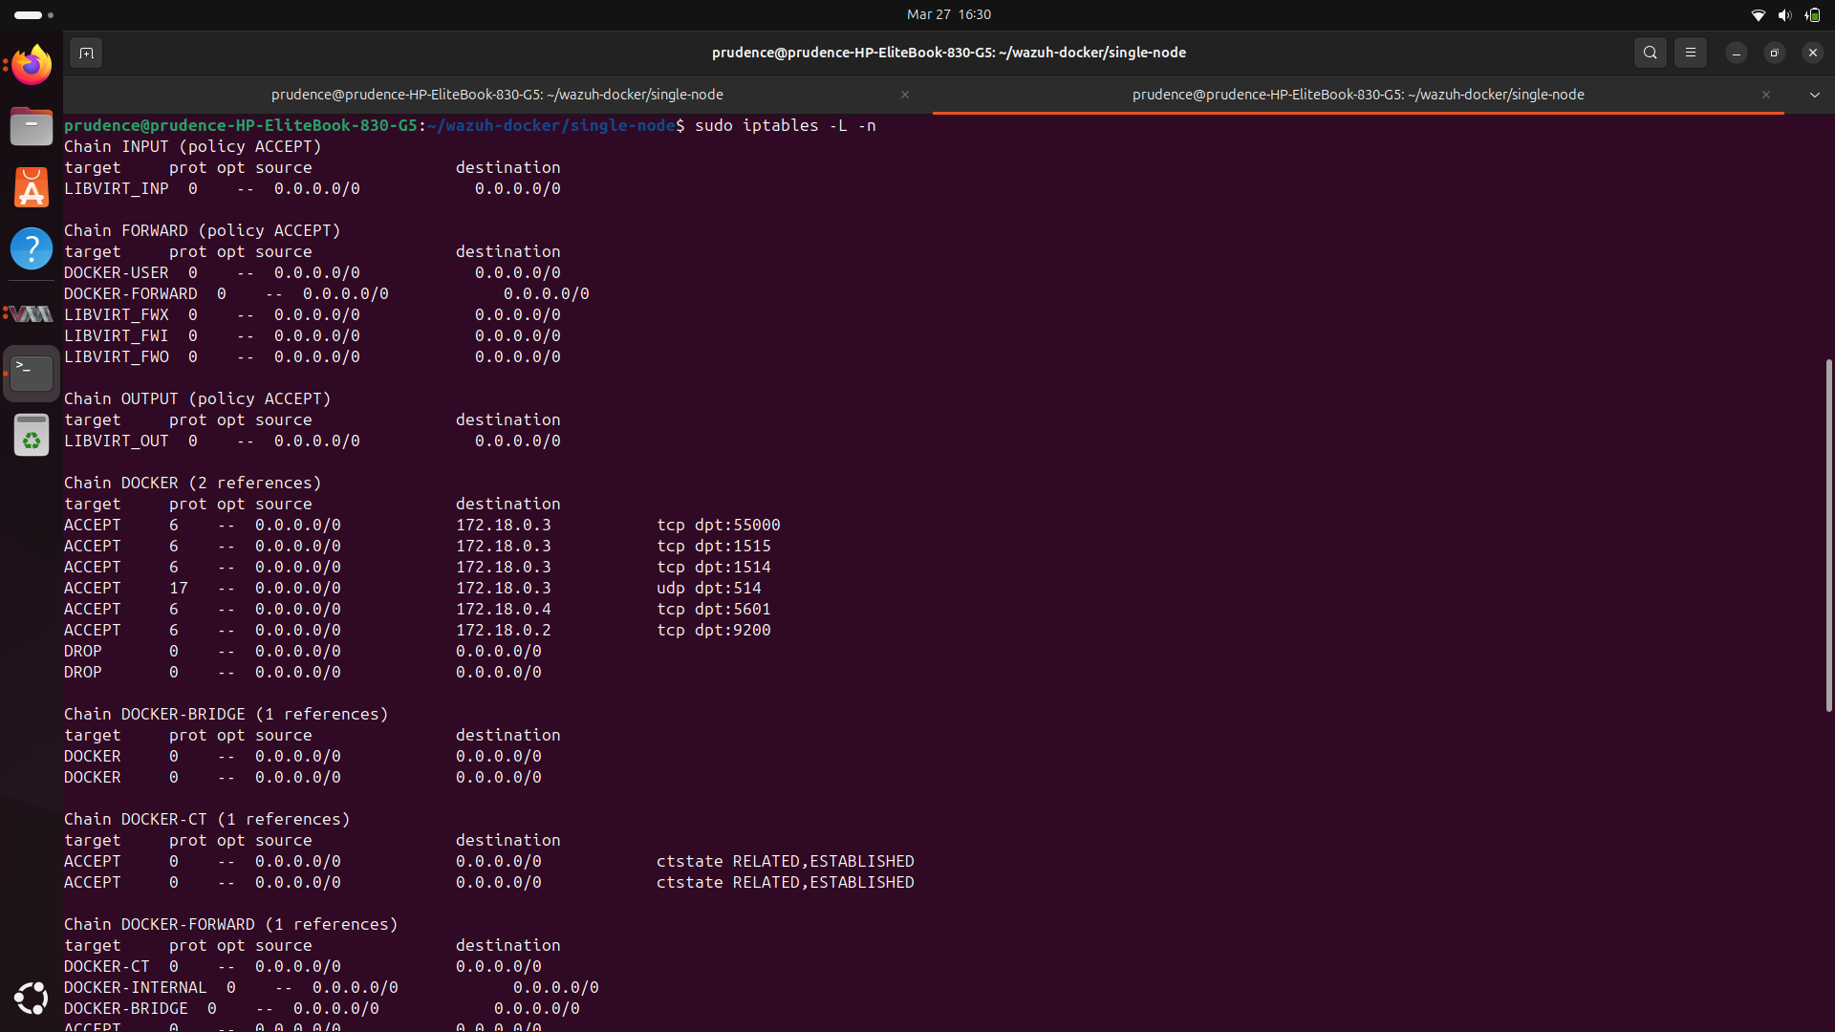
​6. CONCLUSION & FUTURE WORK
​Week 2 successfully demonstrated that a SIEM is only as effective as the rules and responses configured within it. The environment now automatically defends against brute force and provides deep visibility into file-level changes.

